Domhnach Mór

Ad Majorem Dei Gloriam

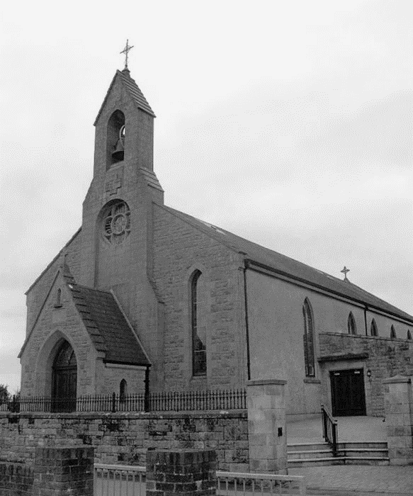
Parish of Donaghmore
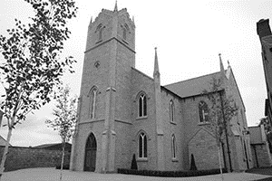
Archdiocese of Armagh



A pure heart create for me O God,

Put a steadfast spirit within me.

Psalm 50

8 June 2025 |  |  |  | Psalter Week 3
Pentecost Sunday |  |  |  | Sunday Cycle C  Weekday Cycle 1
- Next Sunday, 15 June 2025
The Most Holy Trinity – Prov 8:22-31. Ps 8:4-9, R/v 2. Rm 5:1-5. Jn 16:12-15.

Pope’s Intentions for June 2025
That The World May Grow in Compassion
Let us pray that each one of us might find consolation in a personal relationship with Jesus, and from his Heart, learn to have compassion on the world.
Parish Contact Details  Parish Administrator  Fr Brian Slater.  Tel: (028) 8776 1327  Associate Pastor  Fr Patrick Breslan PE. AP.  Tel: (028) 8775 8277  Retired  Fr Patrick McGuckin, PE.  Contact us parishdonaghmore@gmail.com | Weekend Mass Times  Vigil Mass Saturday at 6.00pm Donaghmore  10.00am Mass Galbally  11.00am Mass Donaghmore  Weddings 2025  All couples who plan to marry in 2025 are asked to contact Fr Slater to arrange for the completion of all necessary Church and State paperwork. The completion of the necessary paperwork is a legal requirement and without completion the wedding cannot take place.  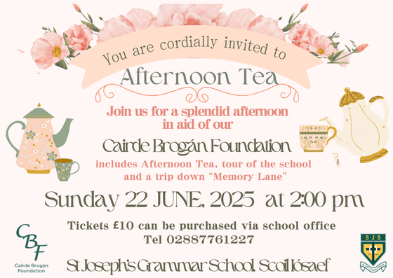  The requirements are: (1) Arrange for your Pre- Marriage Course – see accord.ni for details (2) Contact your local Council Offices for Notification of Marriage Forms (3) Complete Pre-Nuptial Enquiry forms with the Priest of the Parish you live in.
Prayer for The Disappeared
God our Father send your Holy Spirit to enlighten the minds and hearts of those people who can roll away the stone of sadness and anguish long suffered by the families of The Disappeared…
First Friday Sick calls If you know of someone who is sick and housebound, and they would like a visit from a priest.
Please contact Fr Slater with the details so that they may be included on the First Friday list.
Please note that visits with take place before or after the first Friday of the month.

Peace At Last:
O Lord, support us all day long, until the shadows lengthen, and the evening comes, and the busy world is hushed, and the fever of life is over, and our work is done. Then in your mercy, grant us a safe lodging and a holy rest, and peace at last. Amen.
John Henry Newman

*Please note that all Notices for the Domhnach Mór Bulletin must include a contact number and be left at the Parochial House, Donaghmore by 9.00 pm on Wednesday
Anniversary Notices in the Domhnach Mór Bulletin

When requesting an anniversary Mass please write the name of the deceased, the day and date of the anniversary, the chapel and a contact name and number on the outside of the envelope and leave in Donaghmore Parochial House or in either sacristy.

In Memoriam

“It is a holy and wholesome thought to pray for the dead” (2 Maccabees 12:46)

Recently Deceased

Frank Spratt Rose McGee (Altmore)



Anniversaries

Sat 7 June Frank Armstrong, Patsy McGurk & Marie Gallagher Month’s Mind 6.00pm
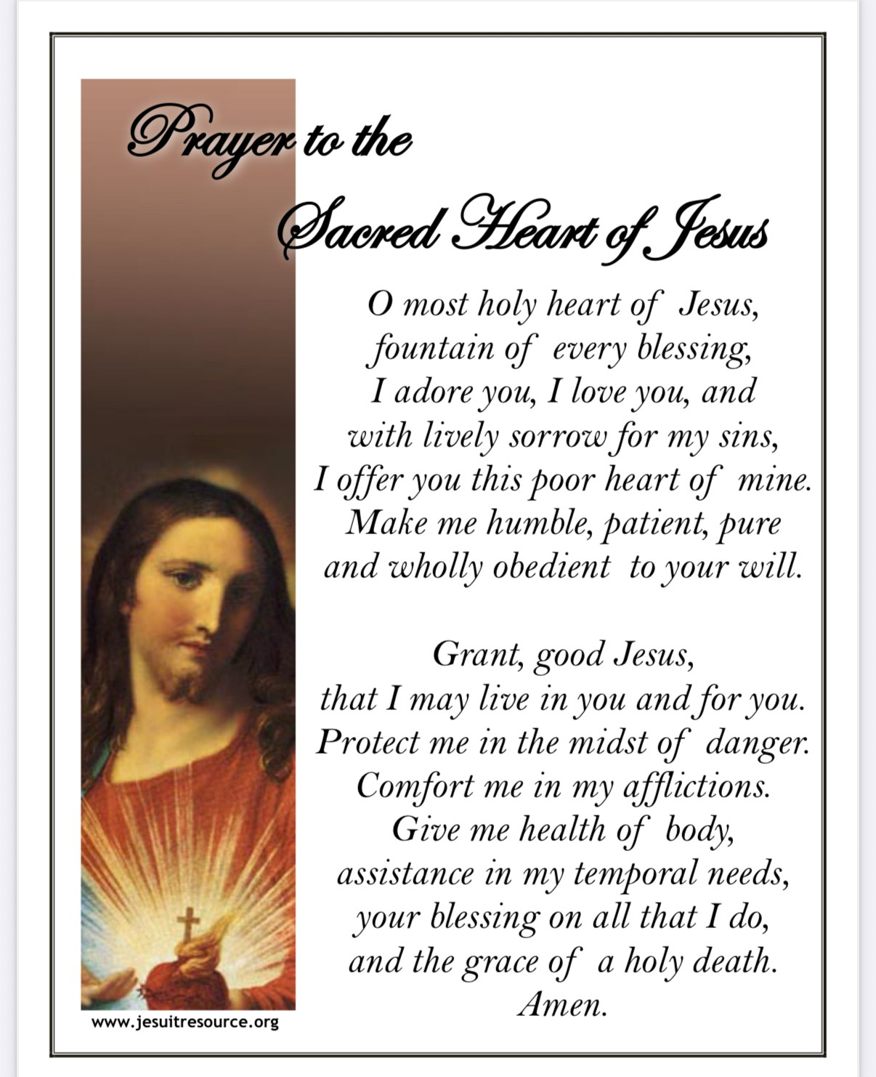
Sun 8 June John McCluskey, Johnnie McElhone, Terry & Mary Kelly, John McRory, Frankie McVeigh
Packie, Johnny and Lizzy Girvan,
Edward, Annie & Eileen Carbery.

Mon 9 June Kathleen Stewart
Wed 11 June Teresa Donaghy

Fri 13 June Gerard O’Hanlon, Hugh & Alice Donaghy
Margaret McVeigh Month’s Mind 7.30 pm (Galbally)
Sat 14 June Joe Casey, Joseph McCrory

Sun 15 June Annie & Dan Mullan,
Owen & Nancy McCool, Kathleen & Paddy Loughran
Maureen Quinn
Requiescant in Pace

Creggan Walk celebrating St Oliver Plunkett 14 June 2025
Jubilee Walk/Pilgrimage celebrating St Oliver Plunkett. As we continue to celebrate this Jubilee Year and as we mark four hundred years since the birth of St Oliver Plunkett and fifty years since his canonisation, a special Walk/Pilgrimage will take place from St Colmcille’s Church, Carrickmore to St Oliver Plunkett’s Creggan on 14 June 2025. The five-mile walk will begin at St Colmcille’s Church at 4pm and walkers will arrive at St Oliver Plunkett’s Church in time for Mass, which will be celebrated by Archbishop Eamon Martin at 6.30pm.
Galbally Community Centre
Lotto Draw: Monday 2nd June 2025: winning numbers were 5, 6, 7, 19
Congratulations to match 3 winners Seana Quinn, Niall Gormley, Vincent Fox, Mary Hackett, Mary Grimes, Paul McAleer, Teresa Kelly. Next draw is Monday 9th June 2025. Jackpot: £1100.00
Monthly Prize Draw – May 2025 Winners £200: Brian Kelly £100: Kevin & Siobhan McVeigh
£100: Martina Kelly. Next draw is Monday 30th June 2025. If you would like to consider joining the monthly prize draw, please contact Fergal on 07713 623264 or Lycrecia at lycreciagcc@yahoo.com

