Domhnach Mór

Ad Majorem Dei Gloriam

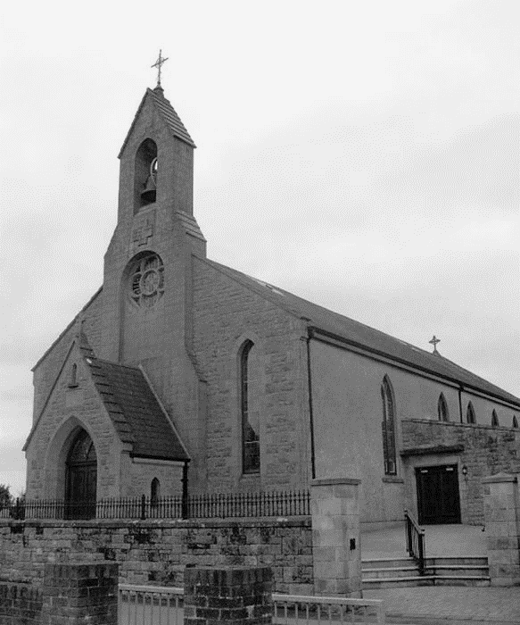
Parish of Donaghmore
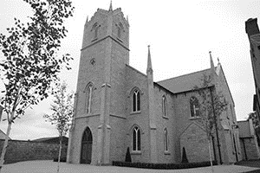
Archdiocese of Armagh



A pure heart create for me O God,

Put a steadfast spirit within me.

Psalm 50

15 June 2025 |  |  |  | Psalter Week 3
Trinity Sunday |  |  |  | Sunday Cycle C  Weekday Cycle 1
- Next Sunday, 22 June 2025
Gn 14:18-20. Ps 109:1-4, R/ v 4. 1 Cor 11:23-26. Lk 9:11-17.

Pope’s Intentions for June 2025
That The World May Grow in Compassion
Let us pray that each one of us might find consolation in a personal relationship with Jesus, and from his Heart, learn to have compassion on the world.
Parish Contact Details  Parish Administrator  Fr Brian Slater.  Tel: (028) 8776 1327  Associate Pastor  Fr Patrick Breslan PE. AP.  Tel: (028) 8775 8277  Retired  Fr Patrick McGuckin, PE.  Contact us parishdonaghmore@gmail.com | Weekend Mass Times  Vigil Mass Saturday at 6.00pm Donaghmore  10.00am Mass Galbally  11.00am Mass Donaghmore  Weekday morning Masses from Monday 7th July – Saturday 12th JulyPlease note that there will be no 9.30am masses Monday to Friday and no 10am Saturday morning Mass between the dates of 7th – 12th July respectively. Anniversaries which fall between these dates will be announced at the weekend Masses and the Mass intention will be offered up at a later date. In the event of a funeral, Mass cover has been organised to facilitate it.  Weekly Bulletin - During the months of July and August there will be no weekly Bulletins printed for circulation. Anniversaries during that time will be announced at all Masses as normal.  O most holy heart of Jesus, fountain of every blessing, I adore you, I love you, and with lively sorrow for my sins, I offer you this poor heart of mine. Make me humble, patient, pure and wholly obedient to your will. Grant, good Jesus, that I may live in you and for you.Grant, Good Jesus, that I may live in you and for you. Protect me in the midst of danger. Comfort me in my afflictions. Give me health of body, assistance in my temporal needs, your blessing on all that I do, and the grace of a holy death. Amen.
Prayer for The Disappeared
God our Father send your Holy Spirit to enlighten the minds and hearts of those people who can roll away the stone of sadness and anguish long suffered by the families of The Disappeared…
First Friday Sick calls If you know of someone who is sick and housebound, and they would like a visit from a priest.
Please contact Fr Slater with the details so that they may be included on the First Friday list.
Please note that visits with take place before or after the first Friday of the month.
Sacrament of Baptism
To be arranged with Fr Slater. Commencing April, all baptisms to take place on a Saturday at 4.00pm.

We welcome into our faith community, Eoin James Tobin, Cillian Sean Whittaker and Logan Sean Grimley on the occasion of their recent baptisms.

*Please note that all Notices for the Domhnach Mór Bulletin must include a contact number and be left at the Parochial House, Donaghmore by 9.00 pm on Wednesday
Anniversary Notices in the Domhnach Mór Bulletin

When requesting an anniversary Mass please write the name of the deceased, the day and date of the anniversary, the chapel and a contact name and number on the outside of the envelope and leave in Donaghmore Parochial House or in either sacristy.

In Memoriam

“It is a holy and wholesome thought to pray for the dead” (2 Maccabees 12:46)

Recently Deceased

Frank Spratt Rose McGee (Altmore)



Anniversaries

Sat 14 June Joe Casey, Joseph McCrory

Sun 15 June Annie & Dan Mullan,
Owen & Nancy McCool, Kathleen & Paddy Loughran
Maureen Quinn, George & Mary Jane Gallagher

Mon 16 June Sean Grant

Tue 17 June Bernadette O’Neill

Fri 20 June Frank Slevin

Sun 22 June James McKane, Anna McKane

Requiescant in Pace

Blessing of the graves in Galbally and Donaghmore - Last weekend the annual blessing of the graves took place and thankfully the weather was kind to us. It was so heartwarming to see so many people turn out to both pray and honour their loved ones who have gone before us. A huge thank you to all those who volunteered with the maintenance and upkeep of our cemeteries right throughout the year and to the stewards who directed the people and traffic and ensured that everyone was safe.
A thank you to those who lead us in prayer with the Rosary and to the altar servers, sacristans, musicians and singers and all those who contributed to our beautiful liturgies. Finally, to thank you for attending to your graves and to the graves of others and having them look so beautiful. Eternal rest grant to them O Lord, may they rest in peace. Amen.

Galbally Community Centre - Lotto Draw: Monday 9th June 2025: winning numbers were 3, 8, 19, 21Congratulations to match 3 winners: Seamus Maguire, Robbie Corrigan, Kathleen Rafferty, Sean Lennon.
Next draw is Monday 16th June 2025. Jackpot: £1200.00
Monthly Prize Draw – May 2025 Winners, £200: Brian Kelly, £100: Kevin & Siobhan McVeigh, £100: Martina Kelly. Next draw is Monday 30th June 2025. If you would like to consider joining the monthly prize draw, please contact Fergal on 07713 623264 or Lycrecia at lycreciagcc@yahoo.com

JUNE: MONTH OF THE SACRED HEART: this year is being dedicated to pray for peace in every facet of the world. On 22nd June a special Mass will be offered at Knock Shrine at which Archbishop Martin will consecrate Ireland to the Sacred Heart of Jesus but has asked that every parish and home joins in this act with the blessing of Sacred Heart pictures at Masses that weekend (22nd/23rd June) and with the recitation of a prayer of dedication at those Masses.
We all know only too well the need for a sustainable peace in so many countries of the world, but also in so many homes and communities in our own land. Please do join in this initiative, as when we all pray only good, no matter how small, can come about.
DIOCESAN CONGRESS ON YOUTH, FAMILY AND FAMILY: will take place on 20th -22nd March 2026. As part of the preparations for this a small number of meetings will take place over the coming months both locally and regionally. The Diocese is looking for representation from each parish which is to include, one parent of a young family, a young person from each Parish aged between 18 and 35 years and any one other individual from every Parish who is actively involved in the life of the Parish and who would be keen to be involved.
The remaining preparatory meetings will take place on 12th November and 4th February in the Glenavon Hotel, Cookstown. If you would be interested in joining this process, please leave your name to the sacristy or Parochial House at any time. Please be assured the responsibility and commitment will not be onerous. Many thanks for considering this request.
An evening with Peace Campaigner Jo Berry St James Hall, Aughnacloy 18 June 2025
We are writing to you today from the Youth Link NI (in partnership with local churches and community groups) with an exciting and incredibly exciting invitation for your congregation.
On Wednesday, 18th June, at 7 PM in St. James Hall, Aughnacloy, we will be hosting "An Evening with Peace Campaigner Jo Berry." Jo Berry is a remarkable individual whose journey has focused on "Overcoming Hatred," "Beyond Revenge," and "Transforming Tragedy into Peace" through "The Power of Empathy" and "Building Bridges Through Dialogue."
This event promises to be a profoundly inspiring evening, offering "A New Perspective" and exploring how we can all contribute to "Building Bridges for Peace." In these times, the message of unity, understanding, and peace is more vital than ever, and we believe Jo Berry's insights will resonate deeply with many within our community.
We genuinely believe that this evening will offer a valuable opportunity for reflection, inspiration, and community building.
Should you have any questions or require further information, please do not hesitate to contact us at 07875547970 or matthew@youthlink.org.uk.
Anam Cara Parent Support Evening 25 June 2025 at 7.30pm
Anam Cara, the organisation that supports bereaved parents, will hold its monthly Parent Support Evening on Wednesday 25th June at 7.30pm in the Armagh City Hotel, Friary Rd, Armagh. This event is free and open to all bereaved parents regardless of the age your child died, the circumstances of their death, or how recent their death was. You do not need to register in advance.
Please note that there will be no meetings in July & August, and we will recommence on Wednesday 24th September We also offer an online support group meeting. To find out more call 01 4045378 or email info@anamcara.ie

